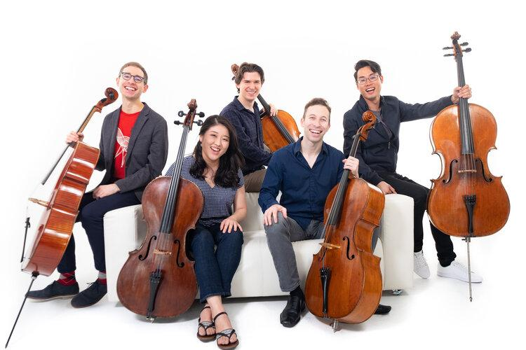
GOLD COAST CHAMBER PLAYERS
Presents

Cello Extravaganza
Saturday, March 11, 2023

Lafayette, CA: The Gold Coast Chamber Players will conclude 35 years in the chamber music community with two more programs. The first is Cello Extravaganza on Saturday, March 11, 2023, at 7:30 pm in the Don Tatzin Community Hall at the Lafayette Library, 3491 Mt. Diablo Blvd. in Lafayette, CA.

The final concert, Souvenir, is April 15. All concerts will be recorded and ticket holders have access to this Digital Concert Hall, making it possible to enjoy recordings of these live performances anytime throughout the season. Come hear why GCCP was voted Best East Bay Concert Series for the second year in a row!

A unique and versatile cello quintet, hailed as “brilliant” and “superb” by Mark Swed in the Los Angeles Times, the SAKURA Cello Quintet is built on the artistry and virtuosity of its members: Stella Cho, Michael Kaufman, Benjamin Lash, Yoshika Masuda, and Peter Myers. Drawing from the rich heritage of a repertoire that spans eight centuries, inventive programs are constructed around conceptual threads, with a commitment to opening new vistas of beauty and expression by showcasing the great warmth and scope of five cellos.

Stunning arrangements of music by Faure, Dvorak, Falla, Debussy, Britten, Schubert, Rachmaninoff, Chick Corea, and Peter Myers provides an eclectic and varied program. The rich soundscape of an ensemble of cellos offers a unique experience for listeners. Artistic Director Pamela Freund-Striplen interviews Sakura members at 7PM before the performance.

TICKETS: $15-45, online: www.gccpmusic.com or By phone: (925) 283-3728
Discounted Subscriptions are available.

CONTACT Pamela Freund-Striplen (925) 283-3728; Gold Coast website
Photo by Shaun Frederickson

####

